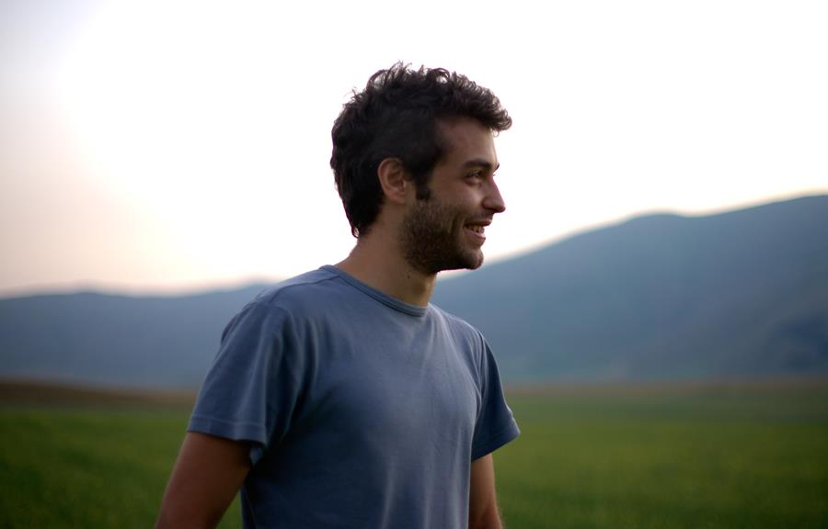
Marco Gentili

Birthday’s date: 21.10.1988
City: Via G. Oberdan n.3, Morrovalle
Country: Italy
Mobile: (+39) 3932201456
Email: marco.gentili@tutanota.com
Website: www.gentilimarco.com
Skype: marco.gentili88

Profile
Graduated in Political Science and International Relations, and graduate to the Master in Political and International Studies at the University of Macerata. I have acquired good communication skills and organization thanks to my previous work experience gained over the years, experiences that have given me the opportunity to forge strong ties with customers, suppliers and those who participated in the activities carried out. I tend to use my analytical skills and to create empathic relationships in any business and so helpful to make available such capacity, together with the school and university knowledge. I adapt to all situations and orders that come to my data in a fast, precise and accurate. I can be flexible and adapt according to the problems that are presented to me trying to be as independent as possible.

Education
Professional Environmental Hiking Guide – AIGAE 2021
L.R. 11 July 2006 - P.F Tourism Marche Region.

University of Macerata from 2015 to 2017
Master's Degree in Political and International Studies
Thesis: "Foreign workers in the agricultural sector in Italy and in the Marche region" - Tutor Prof. Emmanuele Pavolini University of Macerata, Professor of Sociology of Work.
European Union law, the right of rural development, sociology, contemporary history, the EU economy, international politics, social statistics, international economics, macroeconomics of the European Union, advanced English.

Erasmus+ Traineeships 2015
University of Macerata, Italian Institute of Culture, Krakow (Poland)

Course in "Intercultural Mediation and Management of Immigration Services" 2015
Vis - International Volunteers for Development (Rome)

University of Macerata
Political Science and International Relations - Political and Economic degree from 2010 to 2013
Thesis: "The brands of food products between markets and territory" – Tutor Prof. Francesco Adornato, Rector of the University of Macerata and Professor of International Law Agribusiness.

ITAS Matteo Ricci of Macerata 2008
Biological Scientific Diploma 82/100

Experiences of work and Achievements
TEACHER in High School 2 years
Teacher of Law and Economics

PERIGEO ONG ONLUS
, Torre San Patrizio, Fermo (Italy) 5 years
Extraordinary reception center for migrants people.
o I acquired skills as a legal, social and health worker for asylum seekers at the Extraordinary Reception Center in Social Cooperative.
o I have acquired skills and competences in the legal field (municipal registry documents), intercultural, social and health mediation, providing the service to the 120 beneficiaries of the first reception and widespread reception facilities.
o I served as: assistant teacher of the Italian language; secretarial management; logistics; laundry and kitchen; use of vehicles; clothing distribution / management; ordinary cleaning; recreational activities (creation of a football team); conflict prevention and resolution; sending daily reports; conducting inspections and surveillance; spending on monthly and weekly materials.

ITALIAN INSTITUTE OF CULTURE - ERASMUS+
, Italian Institute of Culture, Krakow (Poland) 2015 (3 months)
- I acquired new skills for the management of cultural events and entertainment public relations with the Director and the help of his staff.
- I acquired many skills and techniques in a office of the Ministry of Foreign Affairs.
- I created a collaborations with many public and private institutions and people inside and outside the Institute.
- I have organized and managed scholarships for students of Italian language who want to come in Italy for to study.

F&B ASSISTANT – SEEDS VOLUNTEERING FOR ICELAND
, Volcano Huts - Reykjavik Thorsmork (Iceland) 2014 (5 months)
- Worked as waiter in a hut/hotel close Reykjavik in the National Park of Thorsmork.
- To be assigned to more activities as merchandising and stock logistics and considerably improved the general organization. Worked as receptionist and assistant in the kitchen and in back office.
- Acquired the ability to understand the best way to approach and deal with different customers and improved my english. Created positive relationships in a multi-cultural team.
- SEEDS Iceland is an Icelandic non-governmental, non-profit volunteer organisation designed to promote intercultural understanding, environmental protection and awareness through work on environmental, social and cultural projects within Iceland.
F&B ASSISTANT BARMAN AND RECEPTIONIST
, Villa Quiete S.r.l. - Macerata (Italy) 2013 (6 months)
- Worked as waiter, barman, receptionist in a hotel of four stars.
- Acquired the ability to understand the best way to approach and deal with different customers and improved my skills, ability and english.
- Ability to work effectively within a team and to coordinate different members.

STATISTICAL INFORMATION SYSTEM AND MANAGMENT
, Regione Marche - Ancona (Italy) 2013 (3 months)
- Improved data analysis skills and ability to easily acquire proficiency in using new software.
- Elaboration of statistical data.
- Statistical detector of Regione Marche
PROMOTER INSURANCE
, Fondiaria S.a.i. - Macerata (Italy) 2011 (6 months)
- Employed front/back office in a insurance office.
- Worked archive and given information about insurance policies.
- Ability to work effectively within a team and to coordinate different employed inside the office.
- Help with general duties.

THE NATIONAL CIVIL SERVICE
, The public Hospital - Macerata (Italy) 1 year
- Helped the old people carry them from their home to the hospital for specialist visits.
- Proved successful to stimulate the elderly to acquire his independence and overcome his disease in a creative way.
- Help with general duties the office of first aid.

SEASONAL JOBS
During my studies I worked in seasonal jobs for agriculture (harvest), waiter in many hotels, restaurants, huts for guarantee me a minimum of economic self-sufficiency by the family.

Logical and Interpersonal Skills
- Co-founder of “SottoRadice”, non-profit association that operates at regional level for the defense and promotion of the region and its culinary peculiarities, recovery and reuse of abandoned urban spaces, the discussions with the national and international cultural diversity.
- Ability and eagerness to adapt my skills in new contexts and situations and to cooperate with a team due to my several team experiences.
- Strong confidence and great ability to positively influence people acquired while working as volunteer assistant during the National Civil Service.
- Driving licence released 21.01.2007.
- Europass Mobility Erasmus+

Languages and Computer Skills
Italian: Mother tongue
English: Level B1 - intermediate
Spanish: Level A2 - basic
Computer skills: European Computer Driving Licence ECDL, Windows XP-7-8, Mac OSX and all related software: Photohosp CS6, Premier CS6, Lightroom 5, MS Office 2012, Wordpress, HTML.
I realized my website of photography using Wordpress and html language: www.gentilimarco.com.

Interests
I’m interested in artistic activities as photography and travel in many countries of Europe, that I can spread my creativity. I have organized and set up several exhibitions and won some national photo contests. I love any challenging activities as mountain excursions, nature and wildness. I like reading books, listen music, watch movies.
The Photography for me is civic engagement, political, ethical, cultural and artistic. I live the Photography as an identity document, as an interpretation of what surrounds me, but above all as a salvation and as truth.

